MAP1_14
Quick Start

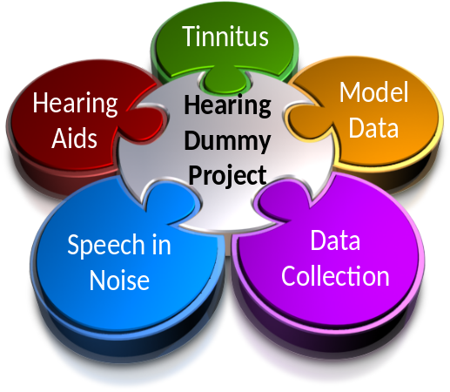

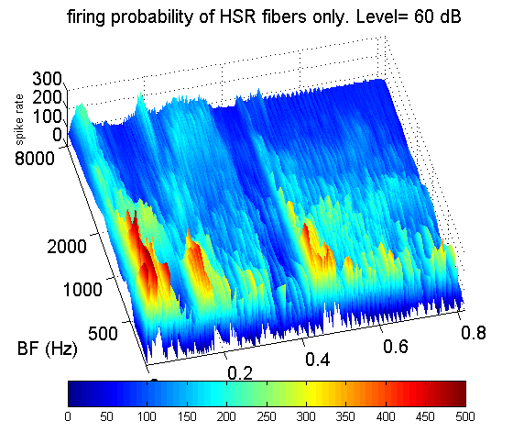 | Hearing Research Lab  University of Essex  2011  Volume 1, Issue 1

Contents
1. What is MAP1_14? 4
1.1. What can I do with it? 4
2. Installation 5
2.1. Software architecture 5
3. Demonstration programs 6
3.1. demoTwisterProbability 6
3.2. demoTwisterSpikes 7
3.3. Auditory Nerve Tuning Curve 8
3.4. Two tone suppression 9
4. User code 11
5. MAP1_14 architecture 13
5.1. Model code 14
5.2. Segmentation 15
5.3. Parameters 15
6. MAP1_14, accessing the output 17
7. Displaying the output 19
7.1. showMAPoptions 19
8. Physiology check-up 20
9. Psychophysics using MAP 22
9.1. Auditory profiles using multiThreshold 22
9.2. Generating a model psychophysical profile 24
9.3. Exploring parameter changes when measuring profiles 27

Distribution
This software is freely shared on the understanding that the recipient accepts full responsibility for how it is used. The author makes no guarantees of any kind by sharing this software. If you know someone who wants a copy, please refer them to the author who will send them the latest bug-free version of the software. Otherwise, old versions circulate to the detriment of our reputation!
This is work in progress. Please send comments, criticisms and suggestions to the author rmeddis@essex.ac.uk

This guide
This is a short guide intended to allow users to get started quickly. It invites the reader to try some demonstration programs and gives a general overview of how the MAP software works. A more detailed description of the model is given in the ‘MAP1_14 technical description’ document.

What is MAP1_14?
MAP1_14.m is the latest version of the Matlab Auditory Periphery (MAP) model from Essex University, UK. It is a computer program that simulates all stages of the auditory periphery up to the auditory nerve (AN) and into the brainstem.
MAP1_14 now has efferent functionality including both acoustic reflex and MOC efferent function.

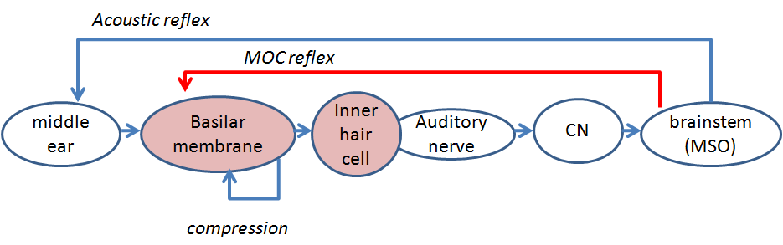
Figure 1: Schematic of the auditory pathway modelled by MAP1_14. Each shape represents a separate stage of signal processing in the auditory periphery.
The model is realised by systems of equations that are described in the accompanying document MAP Model Technical Description.

What can I do with it?
MAP1_14 can be used to:
- Process acoustic waveforms (e.g. tones, speech) to generate multi-channel representations at different levels in the auditory periphery including tympanic membrane, stapes, basilar membrane (BM) displacement, inner hair cell cilia displacement, receptor potential and auditory nerve. Additional representations are possible at brainstem level in terms of neuronal responses including chopper and primary-like responses in the cochlear nucleus (CN). Second level neurons can also be simulated.
- Illustrate basic physiology experiments in the auditory periphery.
- Generate auditory features for automatic speech recognisers.
- Demonstrate a range of psychophysical phenomena such as absolute threshold, threshold as a function of duration, forward masking, threshold masking curves (TMCs), psychophysical tuning curves (PTCs). These demonstrations use the same multiThreshold software as used to measure these phenomena in human subjects.
- Make individualised ‘hearing dummies’. Models of the hearing characteristics of a particular person.

Installation
The software comes in a zipped folder called MAP1_14.
Unzip the folder and place it anywhere in the main memory.

Software architecture
The folder structure has been designed to minimize MATLAB path problems and enhance portability.
The beating heart of the system is a program containing the model equations. It is called ‘MAP1_14.m’ and can be found in the folder MAP1_14\MAP. The equations are described in the more comprehensive MAP Model Technical Description document.
The parameters to be used with the MAP model equations are combined in a single parameter file. Different parameter files exist to model both normal and impaired hearing. These files are located in the folder MAP1_14\ parameterStore
The folder MAP1_14\demonstrations contains demonstration and test programs. These allow the new user to explore its potential. Some examples are given immediately below.
Another folder, MAP1_14\multithreshold 1.46, contains psychometric testing software normally used with laboratory subjects. This can be harnessed to the MAP model so that the model can be tested in the same way as clinical patients. An introduction to this software, multiThreshold quickstart is located in the folder MAP1_14\Documentation.
The folder MAP1_14\wavFileStore contains acoustic stimuli stored as .wav files in.
The folder MAP1_14\utilities contains utility functions that are shared across programs and can also be accessed by the user.
Users can write their own programs to control the model. These programs should be stored in the folder MAP1_14\userPrograms. The user is strongly encouraged to rename this folder by adding initials (e.g. userProgramsRM.). When sharing software or seeking advice from the author, it is convenient to send this folder for inspection.
When creating new folders, the user is strongly advised to locate them inside the MAP1_14 folder. This allows all paths to be identified as relative to the MAP1_14 folder. This is a great aid when sharing software.

Demonstration programs
To get started quickly, you can use the demonstration programs in the demonstrations folder.
Two programs ‘demoTwisterProbability’ and ‘demoTwisterSpikes’ both take the acoustic input from a .wav file, twister_44kHz.wav, and process it through the model. This .wav file contains the word ‘twister’ spoken by the author.

demoTwisterProbability
The first program, demoTwisterProbability, plots the model auditory nerve response to this acoustic stimulus. Navigate to the demonstrations folder then, in the command window type
demoTwisterProbability
The model processes 21 channels with best frequencies (BFs) between 250 Hz and 8 kHz.
The program plots the model response at four stages (stimulus, stapes, basilar membrane (BM) and auditory nerve (AN) firing rate. This is shown (left panel).
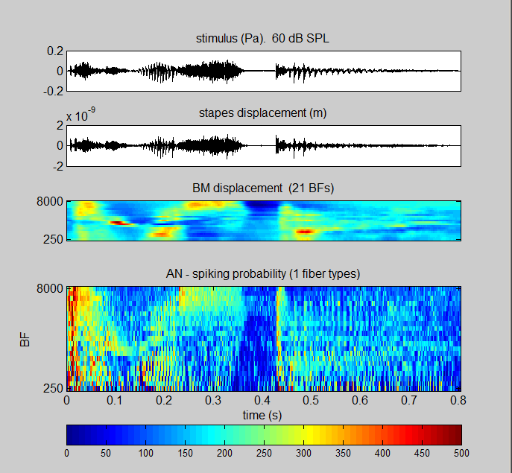 | 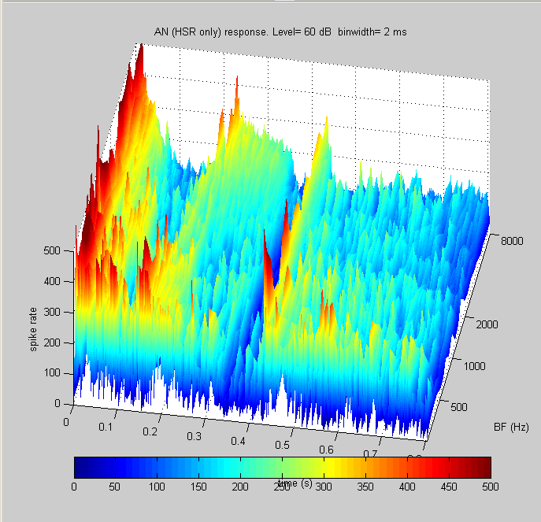

Figure 2: Left panel: Model output for the demonstration file demoTwisterProbability. The input utterance is the word ‘twister’ spoken at an rms level of 60 dB SPL by a male speaker. The model has 21 channels with BFs between 250 and 8000 Hz (evenly spaced on a logarithmic scale). The top three panels represent the signal, the stapes displacement and the basilar membrane displacements respectively. The bottom panel shows the AN response firing probability computed for high spontaneous rate fibers. Right panel: Surface plot of the high-spontaneous rate fiber response. This plot represents the probability of action potentials scaled up to represent firing rates in each BF channel.

demoTwisterSpikes
The second program, demoTwisterSpikes, illustrates a full spiking model. In the command window type
demoTwisterSpikes
It computes the AN response as spikes and then uses these spikes as the input to arrays of neurons in the cochlear nucleus and these units feed other units higher in the brainstem. In both cases the neurons are configured as simple chopper cells with regular firing patterns. The brainstem circuitry is still fairly primitive and exclusively excitatory.
21 BF channels are used in this example. The spike plots are horizontal rows (rasters) of spikes. Each row is the simulated spiking pattern of a single hisgh spontaneous rate (HSR) AN fiber. There are 100 AN fibers in each channel in panel 4. In total this is 21 x 100 = 2100 fibers. In panel 5 there are 10 CN neurons in each channel in each fiber-type stream in panel 5 (21 x 10= 210 CN neuorns). At the second level, there is one neuron in each BF channel in each fiber-type stream in panel 6 (21 neurons). The main acoustic features visible in the BM panel are best represented in this final stage of neural processing.

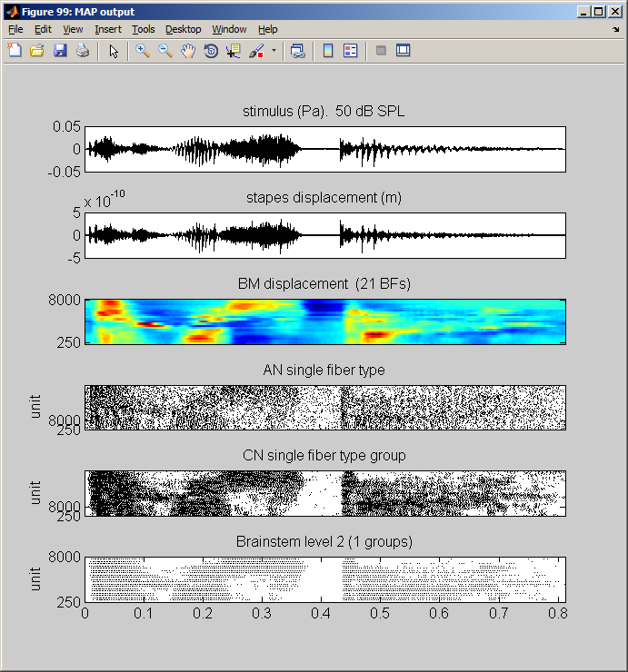

Figure 3: Model response to the utterance ‘twister’. The first three panels are the same as the previous figure (signal, stapes response, BM response). The auditory nerve response (panel 4) is given as a raster plot of spike activity in 21 channels for high spontaneous rate fibers (2100 fibers altogether). The bottom two panels show the spiking activity of simulated chopper units in two successive layers of brainstem activity. All units are programmed as simple chopper cells.

Auditory Nerve Tuning Curve
The third demonstration program, demoTuningCurve, illustrates a physiological experiment to measure the tuning curves of a single auditory nerve fiber. In the command window type
demoTuningCurve

The program plays a pure tone at a range of different levels and frequencies and creates a tuning curve on the basis of the auditory nerve response at a single BF. The tuning curve is extracted from the data using the MATLAB ‘contour’ command. This looks for rates at just 5 dB above spontaneous rate. Spontaneous rate is the firing rate observed at the lowest signal level used.
In this example, the AN fiber has a BF of 4 kHz. This can be changed in the program.
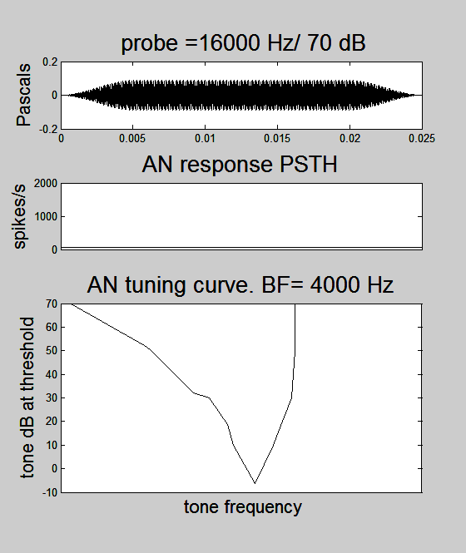

This model is coded for spike probability only (not spikes).

Two tone suppression
The third demonstration program, demoTwoTone, explores the nonlinearity inherent in the model. Navigate to the demonstrations folder then, in the command window, type
demoTwoTone
MAP is run many times. On each run a probe tone is played for the duration of the run. On successive runs, a suppressor tone is added halfway through the run and this is systematically changed in level and frequency across runs. The top panel shows the combined signal (probe + suppressor) for the current run. In a linear system, we would expect the second tone to add to the first tone to produce an increase in the output. The model shows that this is not always the case. On some occasions, the output is actually reduced. This phenomenon is popularly known as ‘2-tone suppression’.
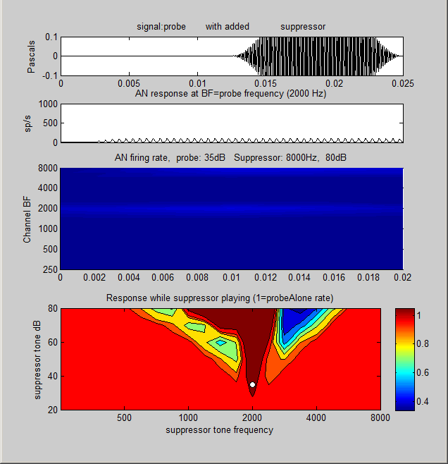 | Intermediate result showing suppression  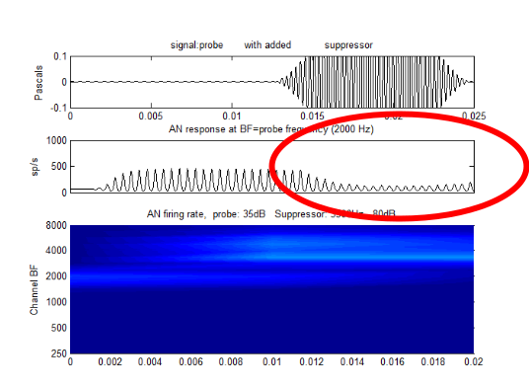
Figure 4: Model output for the demonstration program, demoTwoTone (see text).
In this example a 2 kHz probe tone is played continuously for 25 ms at a level of 35 dB SPL. A second tone is added 12 ms into the run. On successive trials, the level of this second tone is varied between 0 and 80 dB SPL and its frequency is varied between 250 and 8000 Hz. The outcome measures are based on the auditory nerve response of the 2 kHz fiber.
The figure shows the signal in the upper panel and the 2 kHz auditory nerve firing probability in the second panel. This is the panel to watch and where suppression can be seen for certain combinations of level and frequency. The right panel shows an intermediate result with a suppressor tone of 3500 Hz at a level of 70 dB. When the suppressor tone is switched on, the response to the 2-kHz probe tone in the 2-kHz channel is largely extinguished (see the second panel down).
The left-hand panel shows the final trial where the suppressor frequency is 8000 Hz at 80 dB SPL. The third panel shows the response of all 21 channels of the model to this stimulus. The light band in the middle of the display shows that the 2000 Hz tone is generating a maximum response in the 2000 Hz BF channel. The yellow/orange blob at the top right of this panel is the response to the intense, high-frequency suppressor. In a real experiment, this multi-channel response cannot be observed. Only the response from a single fiber can be studied.
When the demonstration program is run, the model response is illustrated in rapid succession. The effect needs to be watched many times to grasp what is happening. Comment/uncomment the pause instruction near line 235 to slow/speed up the movie.
At the end of the demonstration, the bottom panel of the figure will be complete. It shows the response to the combined tones expressed relative to the response to the probe alone. A value smaller than one indicates that suppression has occurred. The contour plot shows that tones close in frequency to the probe tone are excitatory (ratios greater than one). Outside this region the second tone either has no effect or is suppressive.
The small white central dot indicates the level and the frequency of the fixed (probe) tone.
The appearance of the summary panel changes substantially when different probe frequencies and levels are used. When evaluating the two-tone suppressive properties of the model, it is important to choose published animal data and then to replicate the stimulus frequencies and level exactly. Only then is the comparison valid. Most of the parameters of this demonstration can be modified at the head of the program code. Also bear in mind that the strength and extent of two-tone suppression differs substantially across species.

User code
The two demonstration programs are useful for giving some insight into what the model can do but they are not very useful for regular use with the model. There is, however, a program that can be used for this purpose. runMAP1_14 is a general purpose program that is designed so that the user can make changes with a view to exploring more thoroughly the potential of the software. The program is written with comments and accessible code that offers a range of options. Hopefully, these should be self-explanatory as you read through the program. You can find this program in the MAP1_14\demonstrations folder.
Make a copy of this program, put it in your user folder and give it a new name (e.g. myRunMAP). If the program is run in the form supplied, you should get an output that looks like this after rearranging the figures. Bear in mind that small changes in any one of many parameters can substantially change the appearance of this figure, your images may look qualitatively different from this.
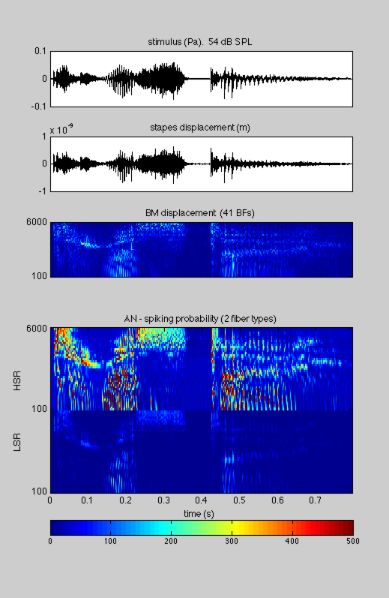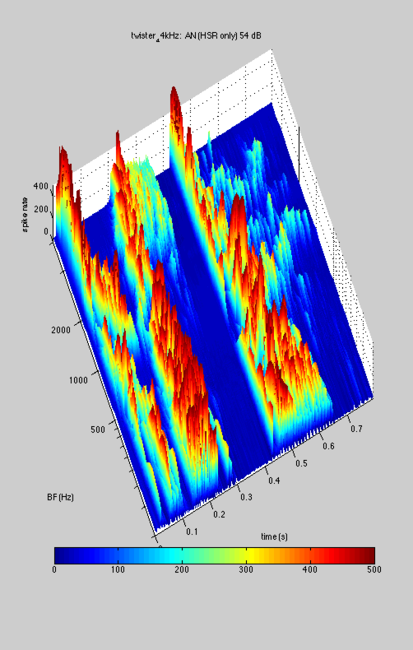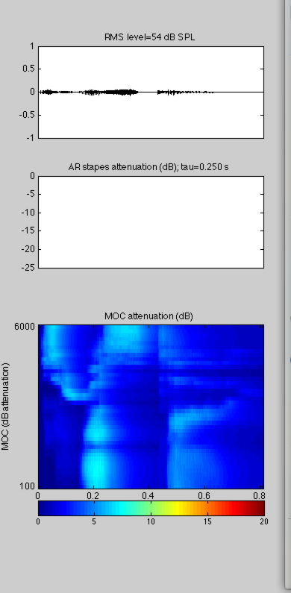
Figure 5: runMAP1_14; a ‘hands-on’ program for users to explore the MAP model.
Left: model output in probability mode in response to the utterance ‘twister’. Panels are (top) original signal, (second) stapes response, (third) multi-channel BM response, (bottom) multi-channel, AN response for two types of AN fiber (high-, and low-spontaneous rates)
Middle: 3D image of HSR AN response (based on the top section of the bottom panel of the left-hand figure).
Right: summary of efferent activity. Panels are (top) original signal), (middle) attenuation due to the acoustic reflex (not activated at this level) and (bottom) multi-channel attenuation pattern due to medial olivo cochlear (MOC) reflex.
Basically, this code generates an acoustic waveform scaled in Pascals and presents it to the model. The program user has a range of options that can be selected by modifying the program code; the stimulus can be pure tones or the input from a .wav file, a pure-tone or harmonic signal (rms). The level can be adjusted, the model can be run in ‘probability’ mode or ‘spikes’ mode and the number and frequency range of the channels can be changed. Don’t forget to make a copy of the original in your userPrograms folder before modification!
Read through the program to familiarise yourself with how it works because this is a good starting point for building your own program by modifying this one. It is a useful exercise to run this program after changing some of these values to see the consequences.
Efferent effects. These are new to MAP1_14 and remain experimental. runMAP1_14 generates a third figure showing how the efferent functions have been activated. In this example (using a 55-dB speech signal) the AR reflex is only not activated (because the intensity of the tone is low). The MOC reflex (in the lower panel) has a much lower threshold and is strongly activated.
The AR can be demonstrated more effectively by selecting a pure tone signal and presenting it at 80 dB SPL. The AR attenuates the stapes response when activated.

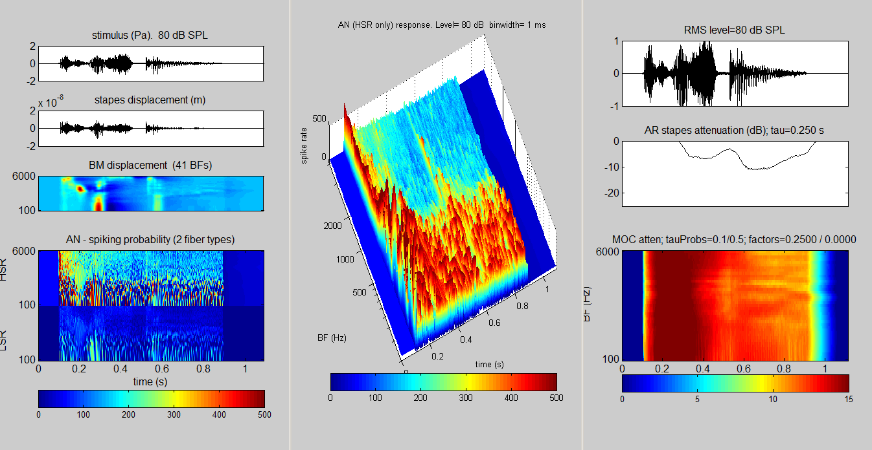
Figure 6: runMAP1_14; stimulus is the speech utterance ‘twister’ played at high signal level so as to activate the AR. Left: model output in probability mode. Middle: summary of efferent activity. Right: 3D image of HSR AN response. Note the reduction of the stapes response (left figure, second panel down)..

MAP1_14 architecture
This section is intended to give a brief introduction to the functioning of the model itself for those who wish to understand how it works or who may wish to improve it with further insights. More details can be found in MAP1_14Model description also in the documentation folder.
The two demonstration programs, demoTwisterProbability and demoTwisterSpike,s use different model architectures. In both cases MAP is structured as a cascade of stages with two feedback loops.

Probability model  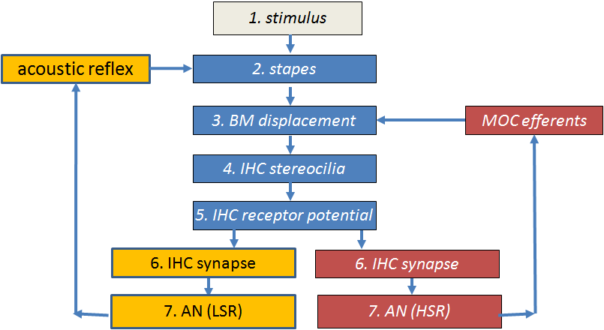 | Spiking model  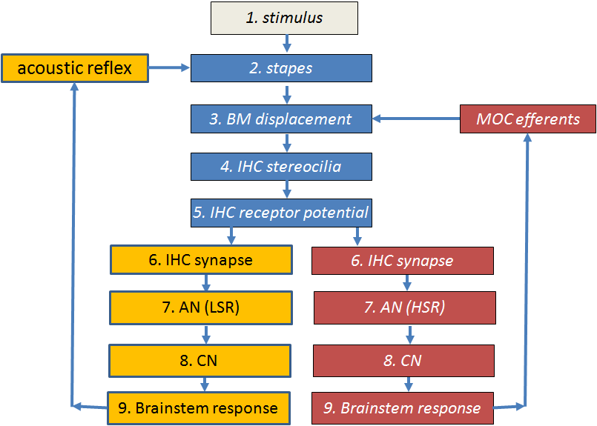
Figure 7: Flow diagrams of the two models implemented in the demonstration programs

Probability model. After the inner hair cell stage, the model bifurcates to give two streams; one for HSR fibers and one for LSR fibers. The probability model ends at the AN fiber stage. The acoustic reflex (AR) and medial olivo cochlear (MOC) efferent feedback loops are fed back from the HSR and LSR paths. This is not physiologically accurate but it provides a useful approximation for users who want rapid computation.
Spiking model. This takes the spiking output of the AN fibers and feeds them through two brainstem stages. The first brainstem stage simulates CN neurons and the second stage simulates activity in the medial superior olive (MSO). It is this second stage that is used as the source of the feedback control signals (efferent activity). This is a more accurate representation from a physiological point of view than the probability model but is slower to compute.
Efferent effects. The AR efferent activity derives its input from LSR fibers which have high thresholds. This helps to guarantee that the AR is active only at high signal levels. The MOC efferent activity derives its input from all fibers including HSR fibers which have low thresholds. This detail is purely speculative in the absence of definitive anatomical evidence.

Model code
MAP1_14.m is the core program containing code that simulates the response of the auditory periphery. It is a single program file containing all instructions for executing the model. It is located in the MAP1_14\MAP subfolder.
The function call is
MAP1_14 (inputSignal, sampleRate, BFlist, MAPparamsName, ...
AN_spikesOrProbability, paramChanges)

inputSignal is a single row vector in Pascals. (It is a row vector because the model code always regards the x-axis of a matrix as the horizontal time axis.) It is single row because the model only processes mono signals
sampleRate is the inputSignal sample Rate (Hz)
BFlist is a vector of BFs (in Hz). If this is specified as ‘-1’, the list of BFs is based on the default values specified in the model parameter file (see immediately below).
MAPparamsName e.g. ‘Normal’, is a string used to make up the name of a model parameter file (e.g. ‘MAPparamsNormal’). The parameter file contains all of the parameters of the model. Parameter files are always located in the folder called parameterStore
AN_spikesOrProbability =’spikes’ for full model generating individual spikes in AN as well as simulation of brainstem neuron activity.
=’probability’ for AN model based on spike probabilities. This option computes faster than the alternative ‘spikes’ option
paramChanges is a cell array of strings containing commands to make last-minute changes to the model parameters after loading them from the MAPparams<*> file (see below). This can be omitted.

There are roughly 1500 lines of code representing all of the peripheral auditory processing stages. These lines are divided into two groups. The first 650 lines or so are purely concerned with pre-allocating memory and establishing constants to be used in the computations that come later. These lines serve to speed up the execution of the main body of the code. The second half of the code contains the equations that simulate activity at each stage. These equations are described in the companion document MAP1_14Model Description.

Segmentation
The model is evaluated in short segments to allow for efferent feedback (AR and MOC) to be implemented. The segments are typically 10 ms long. This is slightly shorter than the feedback delay of the efferent system.

Parameters
The model parameters are established by a .m file to be found in the ‘parameterStore’ folder. For example, MAPparamsNormal.m is a file containing a recommended set of parameters that aims to simulate normal hearing. MAP1_14 executes this parameter file before running the model. Examine the MAPparamsNormal file in the parameter store to become acquainted with the parameters required by the model. It is a very substantial list.
The parameters in the MAPparamsNormal file are simply the values that the author has found to be the most satisfactory in recent months. They are not perfect. If you wish to use them for research purposes, you should ask the author (rmeddis@essex.ac.uk) for the latest parameters and any documentary support. These are not yet published. The researcher is responsible for the parameters he uses; these are the author’s but you are welcome to them.
The user is free to create new parameter files. The file name must begin with ‘MAPparams’ and be followed by an appropriate identifier, e.g. ‘MAPparamsNormal’. All parameter files should be located only in the MAP1_14\parameterStore folder. One of the aims of this project is to create ‘hearing dummies’ to simulate the impaired hearing of individual patients. Each dummy will have an associated parameter file.
Changing a small number of parameters
Small changes to the ‘Normal’ parameter set can be explored using the paramChanges argument in the call to MAP1_14. See runMAP1_14 for an example. This facility changes parameters while not disturbing the original parameter file. paramChanges is a cell array of strings. Each string is a complete MATLAB statement, exactly as it would occur in the parameter file itself including (important!) the final semi-colon). For example,
paramChanges = {'DRNLParams.a=0;', ‘DRNLParams.g=200’;};

This example makes two changes. It sets the parameter DRNLParams.a to zero. (This disables the nonlinear path in the DRNL model of BM response). It also sets a new value for the gain of the linear path (DRNLParams.g). These parameter changes are applied after reading the MAPparams file and overrule whatever is to be found in the MAPparams*.m function. To set up a string,

MAP1_14, accessing the output
The MAP1_14 function draws no pictures nor does it return any output directly to the calling program. All model results are stored in global variables. These are left behind in global memory when MAP1_14 exits. To access all of these results use the following global statement and all of the data should immediately appear in your workspace.
global savedParamChanges savedBFlist saveAN_spikesOrProbability ...
saveMAPparamsName savedInputSignal dt dtSpikes ...
OMEextEarPressure TMoutput OMEoutput DRNLoutput...
IHC_cilia_output IHCrestingCiliaCond IHCrestingV...
IHCoutput ANprobRateOutput ANoutput savePavailable...
saveNavailable ANtauCas CNtauGk CNoutput ICoutput...
ICmembraneOutput ICfiberTypeRates MOCattenuation ARattenuation

As a familiarisation exercise, run either the demoTwisterSpikes or demoTwisterProbability scripts to generate sample results. Then execute the global statement above in the command window.
Hopefully, the variables have been named so that you can work out what they represent. However, some comments may help the user get started.
All values are international units (m, s, Pa, V, A)
Recovering some of the input choices:
saveMAPparamsName (string) holds the string (e.g. ‘Normal’) used to generate the name of the parameter file used (e.g. ‘MAPparamsNormal’).
savedBFlist is a list of BFs, one per channel in the model. .
ANtauCas is used to define the spontaneous rate of AN fibers. It is a list of calcium clearance time constants controlling activity at the IHC/AB synapse. There is one time constant per fiber type. If the length of this vector is two then both LSR and HSR fibers were computed. If the length is one, then only the HSR fibers were computed.
saveAN_spikesOrProbability (string) indicates whether ‘spikes’ or ‘probability’ computations were requested.
ANprobRateOutput. If MAP1_14 is run in probability mode, the AN spike rate matrix (BF x time) can be found in. If two fiber types are used (e.g. HSR and LSR), this matrix will be twice as large. The top half of the matrix will be the output from the LSR fibers. NB, when plotting this matrix it is conventional to flip it to put the HSR at the top of the picture and to order the BFs vertically from low to high. The sampling interval for ANprobRateOutput is saved in the variable dt.
Recovering some of the output:
ANoutput If MAP1_14 is run in spikes mode, the AN spiking output will be found in the matrix ANoutput. This is a logical matrix (0/ 1). The matrix is, therefore, a raster plot. Each BF is associated with many AN fibers (typically 100). All fibers with the same BF and fiber type are in adjacent rows. For example if we use both HSR and LSR fibers, have 21 channels and there are 100 fibers per combination, we should expect to see 2 x 21 x 100 rows in this matrix (i.e.4100 AN fibers). Remember that there is only a total of about 30000 AN fibers in the human auditory periphery.
The sampling interval for the spiking model is dtSpikes. The sampling rate (1/ dtspikes) is reduced because spikes are relatively sparse. Each row of this matrix is the spiking response of an individual AN fiber.
The output of the early stages of the model is stored in the following variables: (sample rate is 1/ dt)
- OMEextEarPressure acoustic pressure
- TMoutput tympanic membrane displacement (m)
- OMEoutput stapes displacement (m)
- DRNLoutput basilar membrane displacement (m) (BF x time)
- IHC_cilia_output IHC cilia displacement (m)
- IHCoutput IHC receptor potential (V)

The amount of efferent activity can be monitored using the variables ARattenuation (single row vector) and MOCattenuation (matrix BFs x time).

Displaying the output
UTIL_showMAP.m is a general purpose function for reporting and plotting the output from the most recent MAP1_14 call.
UTIL_showMAP (showMapOptions)

UTIL_showMAP is used by the demo files described above. Consult these scripts for examples of how to use it. It assumes that MAP1_14 has recently been run, leaving all of its output in global store.
showMAPoptions is a structure containing a number of flags (0/ 1) indicating the user’s requirements (see below).

showMAPoptions
UTIL_showMAP is able to generate a wide range of displays. These must be selected in the showMapOptions structure. The fields in this structure are all logical (true or false).
showMapOptions.printModelParameters=1; % print model parameters
showMapOptions.printFiringRates=1; % mean activity at all stages
showMapOptions.showModelOutput=1; % plot all stages output
showMapOptions.showEfferent=1; % plot of efferent activity
showMapOptions.showACF=1; % SACF (probabilities only)
showMapOptions.surfAN=0; % ANoutput (HSR) surf plot options modifying surfAN (above):
showMapOptions.fileName=''; % parameter filename for plot title
showMapOptions.PSTHbinwidth=0.001 % binwidth for surface plots
showMapOptions.colorbar=1; % request color bar if appropriate
showMapOptions.view=[0 90]; % angle of the surface plot

printModelParameters prints to the command window all the model parameters used.
showModelOutput plots the output of each stage of processing from signal through to the AN and on to the brainstem response if appropriate
printFiringRates prints in the command window the overall level of activity in the afferent and efferent stages
showACF computes and displays the summary autocorrelation function
showEfferent plots of the AR and MOC activity levels
surfAN generates a 3D plot (surf) of the activity of the HSR AN fibers. fileName, PSTHbinwidth, colorbar and view are all options supporting surfAN

Physiology check-up
MAP is a model based on the known anatomy and physiology of the peripheral auditory system. Its parameters have been chosen to simulate physiological recordings made using small mammals. A number of test programs simulate these physiological experiments as a check that the model is doing what it should be doing. These test programs are in the testPrograms folder.
The test programs, testPhysiology and testPhysiologyProb, can be used to ‘exercise’ MAP to check that it is functioning correctly. To run it you should navigate to the testPrograms folder and type on the command line:
testPhysiology(BestFrequency, parameterFileName) % uses ‘spikes’ mode
or
testPhysiologyProb(BestFrequency, parameterFileName) % ‘probability’
This will evaluate MAP1_14 in a single-channel model with a best frequency of BF using the model parameters to be found in MAPparamsNormal.

A range of measurements are made using a sequence of individual test programs,
- Stapes response at a range of frequencies (Figure 2), testOME.m
- BM I/O function, the MOC elicited by the stimuli and the iso-reponse contour (‘tuning curve) at a number of different response levels (Figure 3), testBM.m
- Various IHC I/O functions (Figure 4) and compares them with published animal data, testRP.m
- (Figure 15), testAN.m
  - (testPhysiologyProb ) AN firing rate I/O function based on actual spikes (top right)
  - (testPhysiology) AN firing rate I/O function based on actual spikes (top right) also CN and IC I/O functions – one function for each of the fiber types selected.
- Synapse response (available transmitter) as a function of time and level (Figure 6). Figure 88 is a contour plot of the same data featuring in Figure 6), testSynapse.m
- (testPhysiology only) Forward masking simulation of an experiment by Harris and Dallos (Figure 7), testFM.m
- (testPhysiology only) AN phase locking assessment based on an experiment by Johnson, testPL.m

More information about the individual tests can be found in the ‘MAP Model Technical Description’ file in the ‘Documentation’ folder or by using the help function in the command window, e.g. help testOME
The graphical output from the function should look like the following.

testPhysiology(1000, 'Normal')
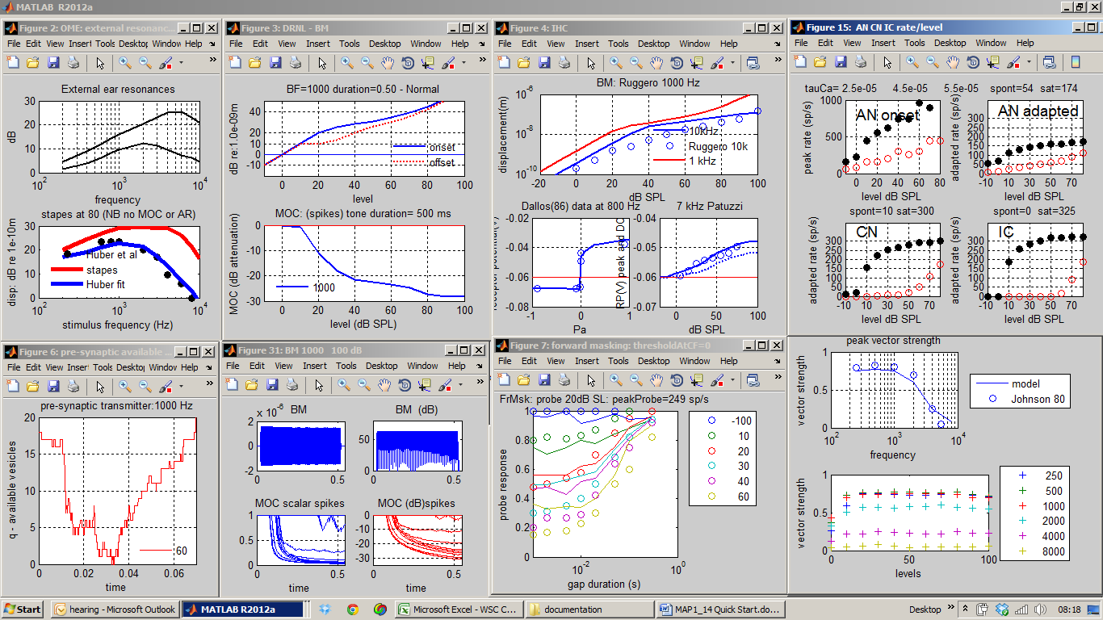
Figure 8: Simulations of physiological experiments using the spikes implementation of the model. These data were generated using:
testPhysiologyProb(1000, 'Normal')
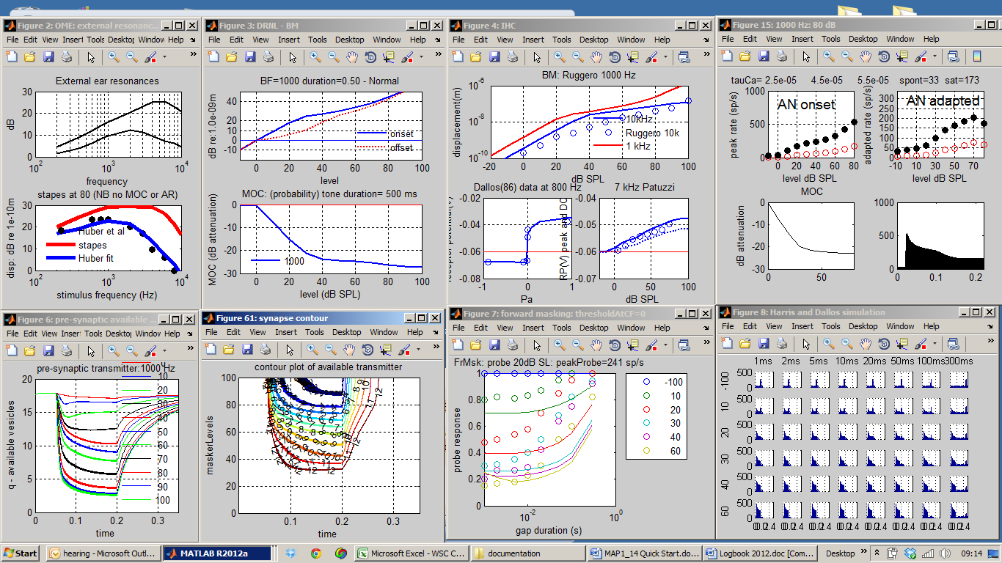
Figure 9: Simulations of physiological experiments using the probability implementation of the model. These data were generated using:

Psychophysics using MAP

Auditory profiles using multiThreshold
The purpose of auditory model is ultimately to model human hearing to such a degree that the model and the individual cannot be distinguished (a kind of Turing test). A step in this direction is to administer the same tests to the model that might be applied to the human listener. multiThreshold is a software controller of a range of psychophysical tests that have been designed to be suitable for testing both humans and the MAP model. Three tests are of particular interest; 1) absolute threshold, 2) psychophysical tuning curves (PTCs) and 3) threshold masking curves (TMCs). These are tests of sensitivity, frequency selectivity and compression respectively.
Here is an example of a hearing profile produced using multiThreshold harnessed to the MAP model and using the MAPparamsNormal parameter set.

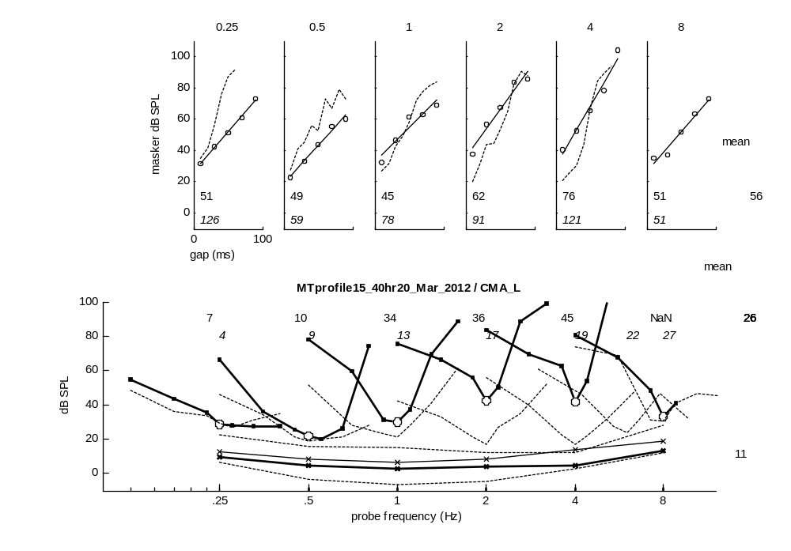
Figure 10: Auditory profile generated using multiThreshold testing software harnessed to MAP using MAPparamsNormal as the parameter file. Top row: temporal masking curves (TMC), an indicator of compression. Middle row: iso-forward masking tuning curves (IFMCs) or psychophysical tuning curves (PTCs), an indicator of frequency-selectivity. Bottom: absolute thresholds for 500-ms tones and for 16-ms tones, (higher line). Dotted lines are data from a human listener with normal hearing.

This profile is similar to a profile for a human listener with normal hearing; original data shown as dotted lines).
Here are two profiles designed to simulate impaired hearing. The continuous, coloured lines are the impaired models (hearing dummies) and faint dashed lines are comparison data collected from a 20-year old male with good hearing.

Reduction in endocochlear potential | Loss of OHCs
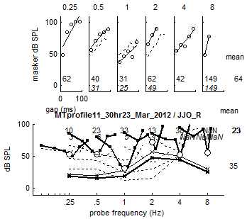 | 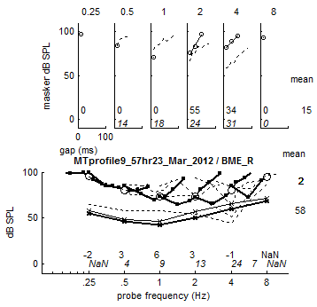
Figure 11: Two auditory profiles generated using multiThreshold testing software harnessed to MAP, a computer model of the auditory periphery. Two different sets of parameters were used. A: the endocochlear potential was reduced to 70 mV but otherwise the parameters were those in the ‘Normal’ file. B: the gain of the nonlinear path in the DRNL filter was reduced to 0, but otherwise the parameters were those in the ‘Normal’ file. The faint lines are comparable patient data selected from our patient database.

In the left panel, the impairment is induced by reducing the endocochlear potential (supplying the inner hair cell, IHC) from 100 mV to 70 mV (IHC_cilia_RPParams.Et= 0.070;)
In the right hand panel, the impairment is created by disabling the contribution of all outer hair cells (DRNLParams.a= 0;)
The multiThreshold software can be found in the folder ‘MAP1_14\multiThreshold 1.46’ and is explained in the associated document: MultiThreshold Manual to be found in the ‘Documentation’ folder.

Generating a model psychophysical profile
A complete profile will be generated using the following procedure
- Navigate to the multithreshold 1.64 folder in the MAP 1_14 folder
- Run multiThreshold.m to display the GUI.

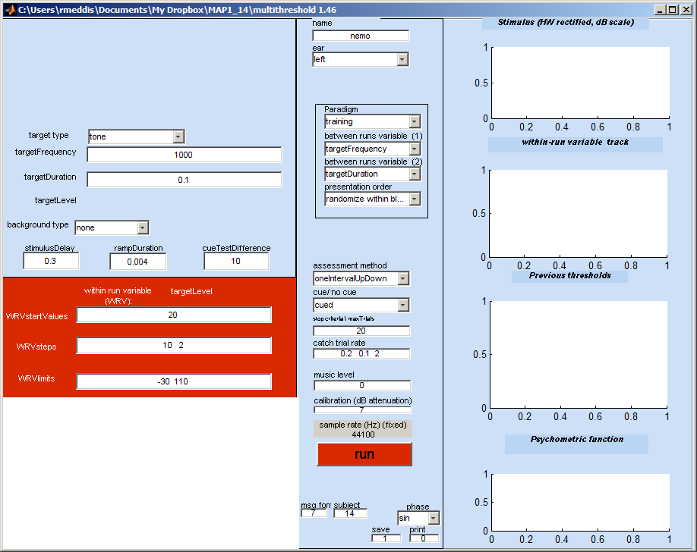
Figure 12: multiThreshold GUI for measuring auditory profiles for both humans and models.

- From the ear menu (middle panel 2nd from top), select ‘MAPmodelSingleChannel’
- From the paradigm menu (below the ‘ear’ menu) , select ‘profile’
- Hit the run button and sit back. A profile should be generated after considerable amount of computation looking like this:

Figure 13: Hearing profile generated by multiThreshold using the computer model as the subject. The ‘Normal’ parameter set was used for this example.
Notes:
- More information on multiThreshold software can be found in MultiThreshold Manual in the documentation folder.
- The model is tested in the same way as the listener except that no cue is used as it is of no help to the model. The stimulus is presented to the model which has to decide ‘yes’ or ‘no’ according to whether or not the probe was ‘heard’ by the model. The measurement software reacts as if the model’s decision was that of a human listener and generates the next stimulus in the adaptive sequence.
- The thin blue lines in the bottom panel with circles are absolute thresholds for 250 ms and 16-ms tones.
- Frequency selectivity: the V-shaped curves are iso-forward masking contours (IFMCs). A short (16-ms) probe tone is presented at 10 dB SL and is preceded by a 108-ms pure-tone masker. The listener is asked to say whether or not he hears the probe tone. The level of the masker is adjusted until the probe is heard on 50% of presentations. Measurements are made for different masker frequencies (over an octave range covering the probe tone). The IFMC is a record of these masker levels. IFMCs are measured for probes at 250, 500, 1000, 2000, 4000, 8000 Hz and for masker frequencies at 0.5, 0.7, 0.9, 1, 1.1, 1.3 and 1.6 times probe frequency.
- Compression: the top panel records 108-ms pure-tone masker levels required to mask a brief, 16-ms probe tone presented at 10 dB SL on 50 % of presentations. The probe and the masker always have the same frequency but the gap between the masker and the probe is systematically varied between 10 and 90 ms. This is called a temporal masking curve (TMC). The masker levels in dB SL are given as the lower of the two lines. The upper line is the same data presented as dB SPL. The steepness of the line is affected by more than one physiological factor. However, if we assume that the recovery from forward masking occurs at a fixed rate, we can infer that the steepness of the line reflects, at least in part, compression of the response to the masker; most likely either at the basilar membrane or the inner hair cell.
- Diagnosis: in the figure above, the model absolute thresholds are high compared to the human data. The IFMCs are a reasonable fit and the TMCs are a good fit at low frequencies but not at high frequencies. The aim, of course, is to find a set of parameters that offers a good fit to all of the data.

Exploring parameter changes when measuring profiles
- The user can seek a better fit by changing the model parameters. The parameters can be found in the parameter file in the folder called ‘parameterStore’. On this occasion the file MAPparamsNormal contains the parameters. This file is specified on the GUI as ‘Normal’ in the edit box called name at the top of the GUI. One way to change the parameters is by altering the parameters in this file and repeating the run.
- If only a small number of parameters need be changed, this can be done on the GUI in the yellow box at the bottom left. This normally contains the empty cell array command paramChanges= {' '}; This can be edited by adding a string inside the quotes, e.g. paramChanges= {' DRNLParams.a=0 '}; This new value is automatically implemented after reading the MAPparams file but before the model is run. At the end of each run, a complete list of parameters and their values is printed in the command window. These can be copied and pasted into the GUI (but remember to add the semi-colon before the final quote.
- If more than one change is required this can be achieved by putting both changes inside their own quotes but separated by a comma (both inside the curly brackets, e.g. paramChanges= {' DRNLParams.a=0 ', ‘DRNLParams.g=500’}; . Line breaks at not currently allowed in this process.
When paramChanges= {' DRNLParams.a=0 '}; is requested we get a profile that looks like this. This parameter change effectively disables the OHC contribution to the BM response.

Figure 14: Hearing profile generated by multiThreshold using the computer model as the subject. The ‘Normal’ parameter set has been changed to simulate outer hair cell (OHC) dysfunction.

